**The User Interface**

**HUD**

In order for a HUD design to be developed, we need to know what information we need to display to the player and how we want to do this.



Figure 1 – HUD: Character Health

This was the initial design for the HUD. The circle would display the currently equipped weapon/ability and the bar was for the health. Another idea that was in the air was that the player would start reverting back to a figurine when they lose health so that the player had a more visual and implicit way of telling how close they were to death, similar in concept to the blood splatters on the screen in some FPS games such as Call Of Duty.

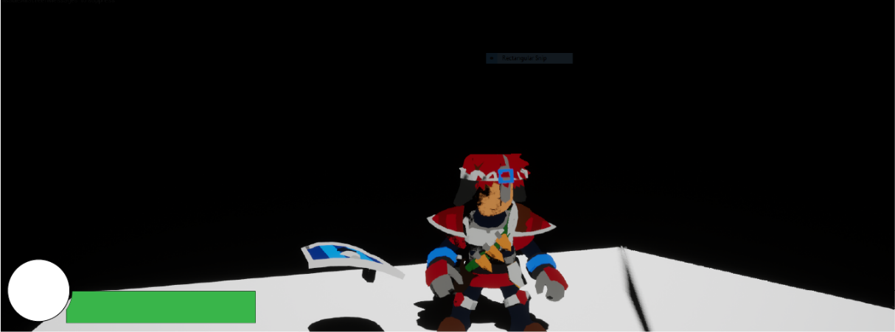

Figure 2 - The HUD in-game

**Possible changes:**

As this is all the information that the player needs to know during gameplay, this is all that is required from the HUD. However, we may add additional elements later as the game evolves.

# 

# **Main Menu**

# For the main menu, the idea we had initially was to use a render target and scene capture actor to use part of the environment as the background of the UI, instead of having a generic background. This would show the player the sort of game to expect and has worked well in other games such as Plague Tale Innocence, which uses a unique environment for the Main Menu UI.

Figure 3 - Main Menu

This is a basic main menu design. This will consist of 3 buttons that will either start the game, to some basic options or quit the application. we will make the UI look better using Abode Illustrator later, but right now we are focused on the getting the basics of the UI sorted and iterate the design.

# **Save Select**

# We’re going to use the previous idea of using a render target, but we’ll a spline track to move the scene capture component to a new space in the world to change the background.

Figure 4 - This is a basic save slot menu. It will have 3 slots to be able to load and save data from.

# **Pause Menu**

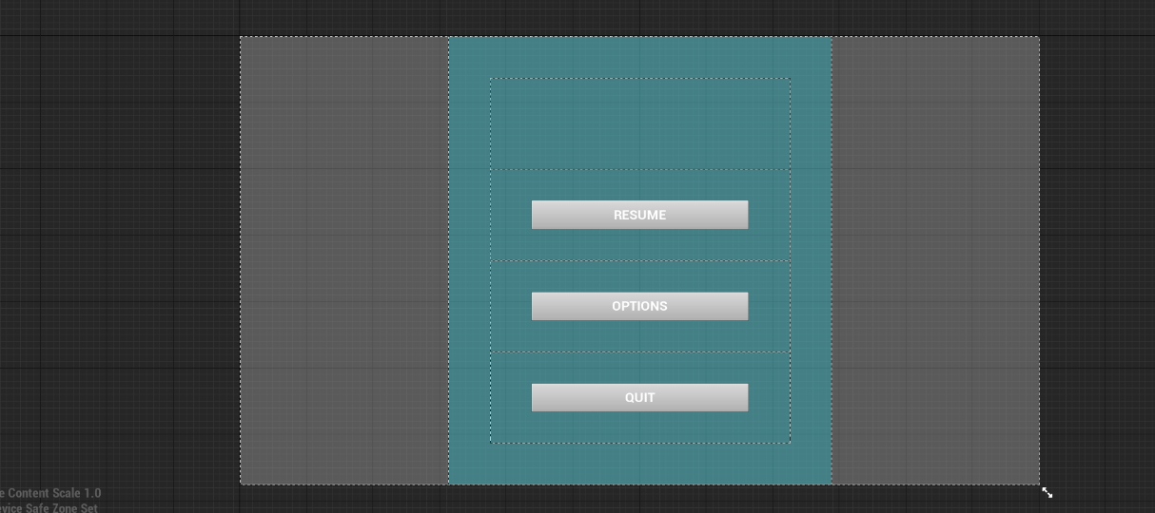

Figure 5 - This is a basic Pause menu

This is a basic Pause menu. It will have these buttons. The buttons will basically do the same to the main menu buttons, except the quit button will take the player back to the level select menu.

# Level Select

# Level Complete

# Enemy Popup